NAME :Sarankumar

Dept : 4- AIDS

DATE :12-07-2024

ACTIVITY : Full Stack Development Activity -1

1. Create a local git repo with the name "MyRepo"?

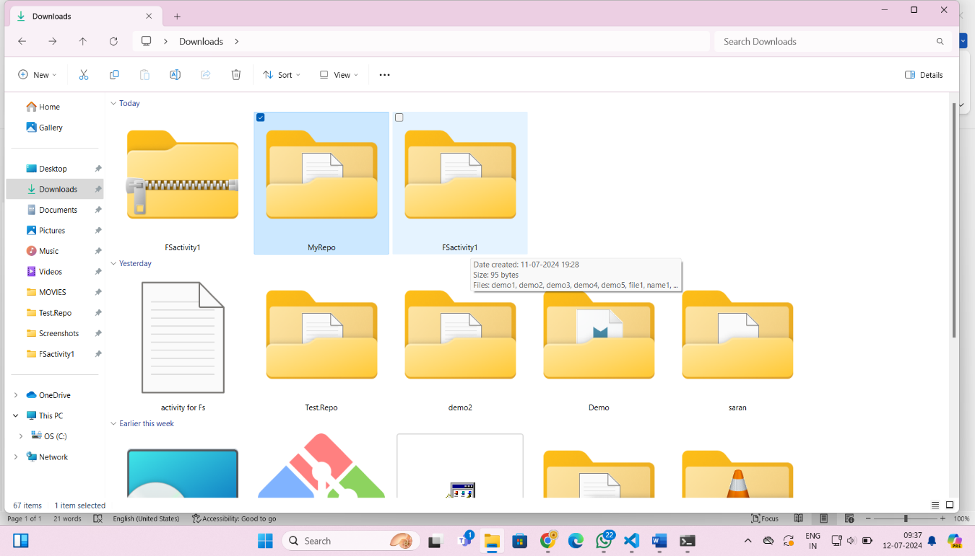

2. create one .txt file, five .c files and five .java files in the working area ?

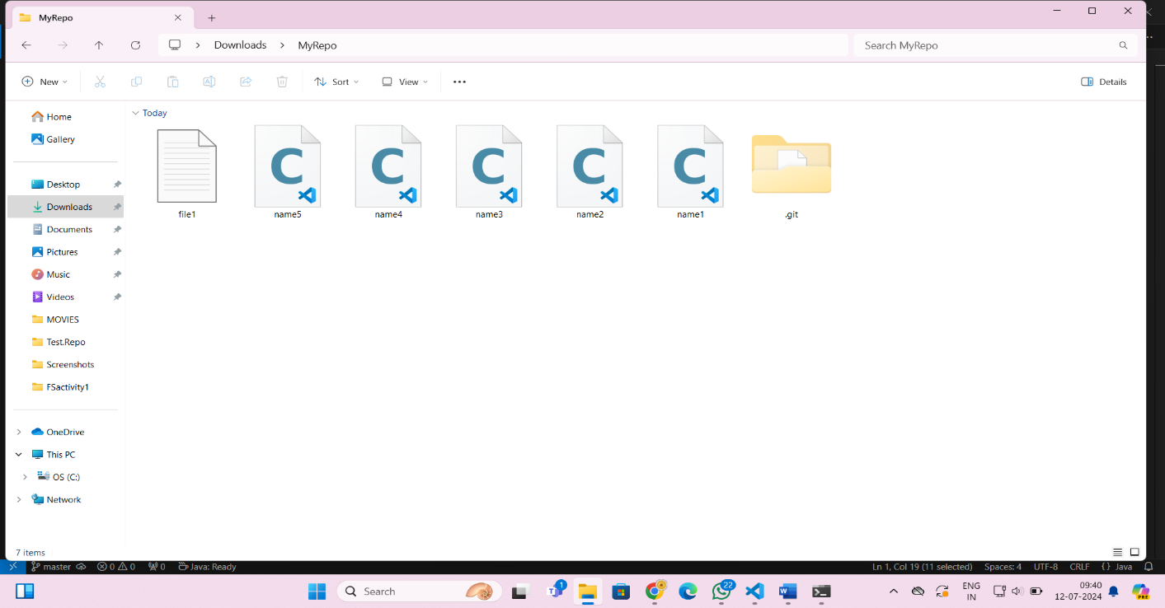

3. Verify the git status ?

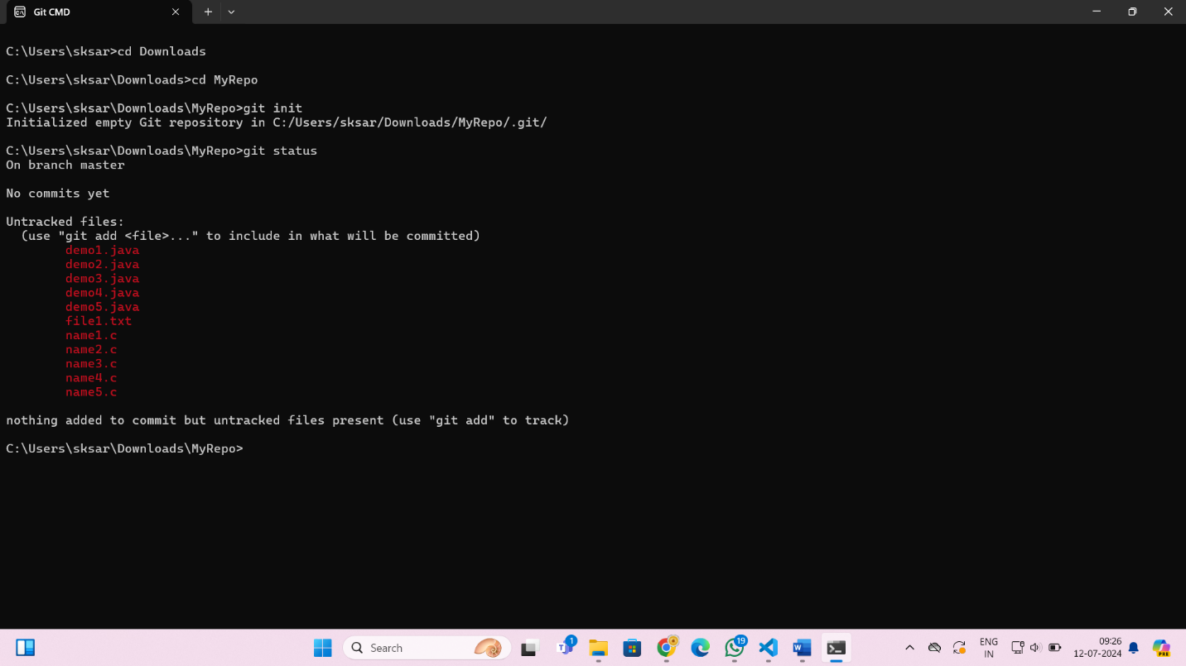

4. Add only the .txt into the staging area ?

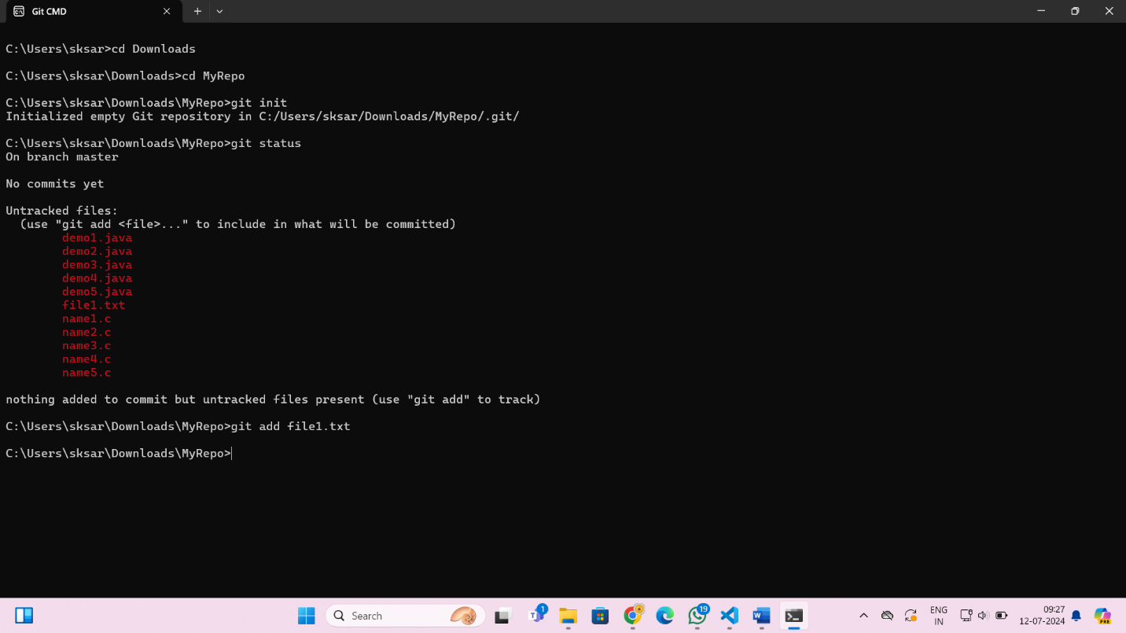

5. verify the git status ?

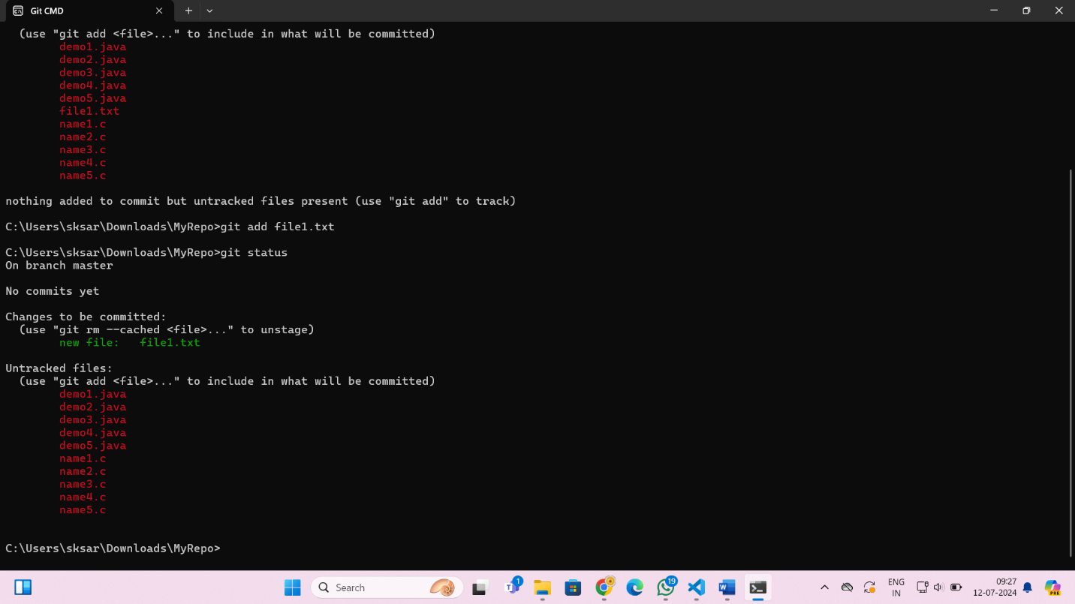

6. Make a commit with the name "TXT Commit" ?

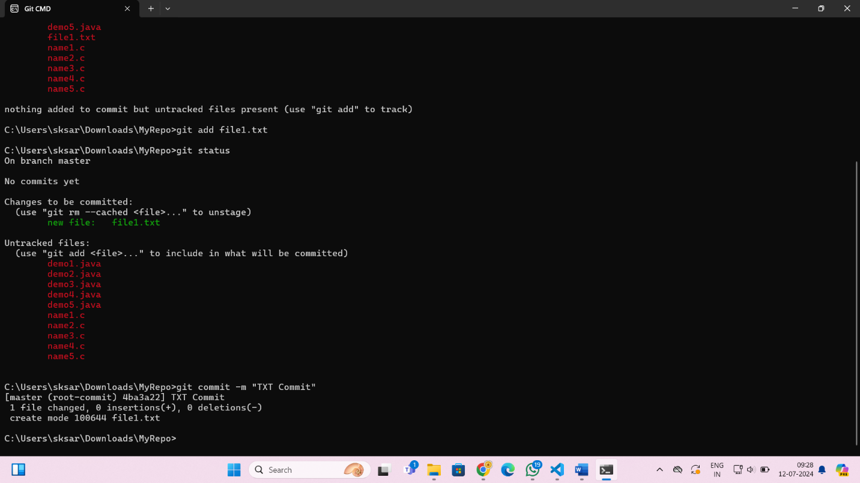

7. Add all .c files into the staging area ?

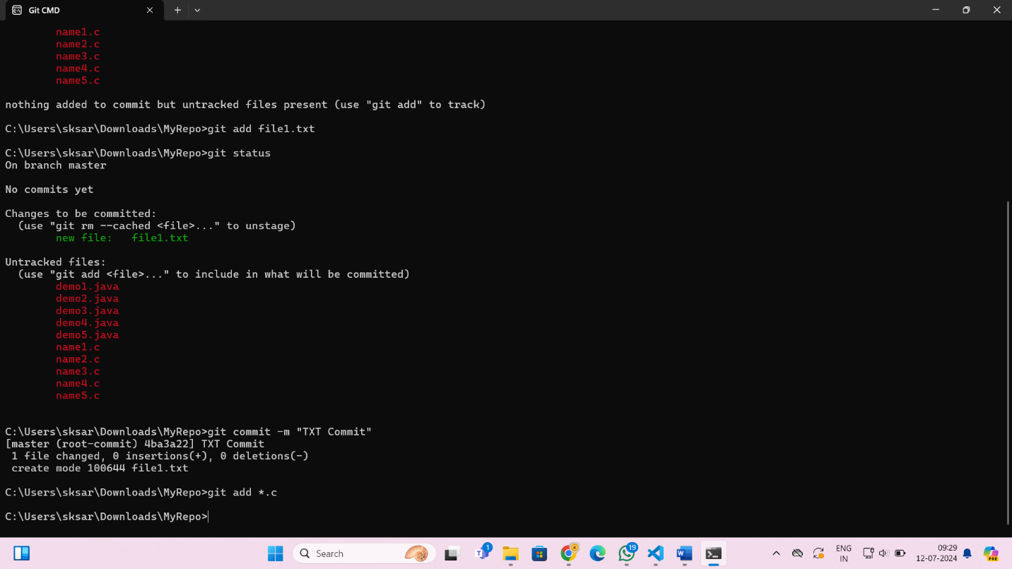

8. verify the git status ?

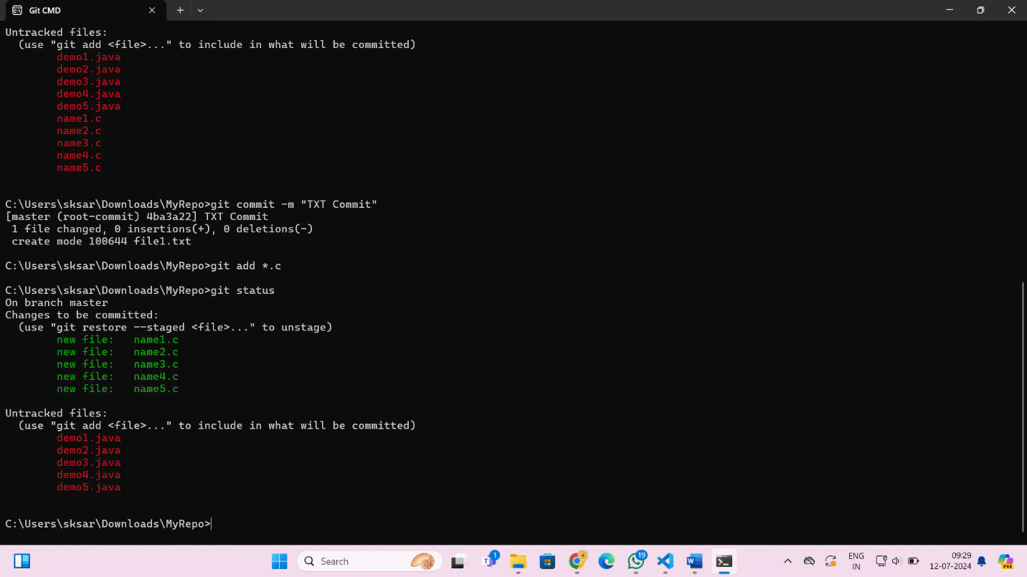

9. Make a commit with the name "C Commit" ?

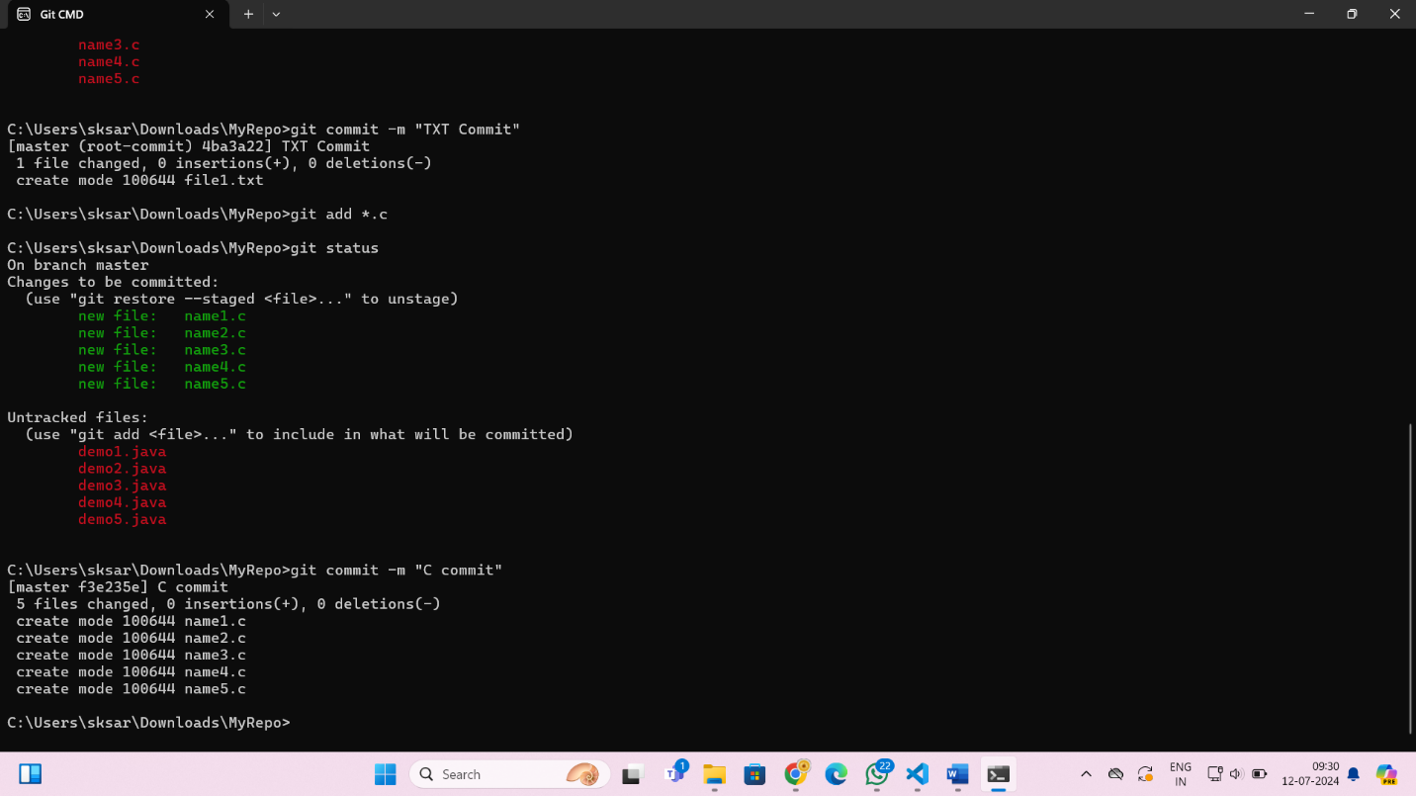

10 .Add all .java files into the staging area ?

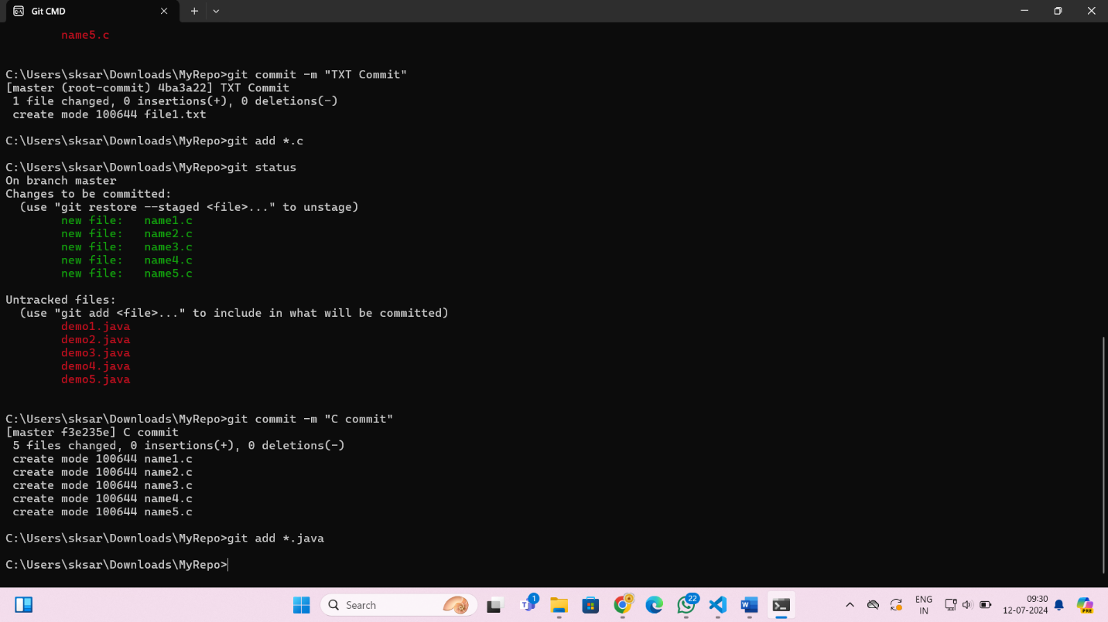

11. verify the git status ?

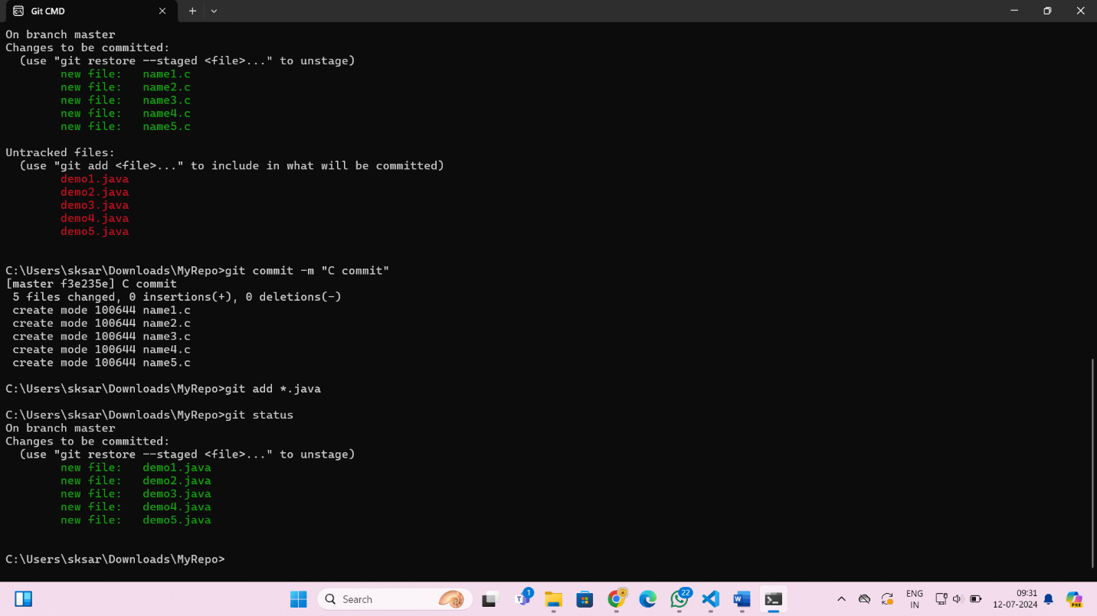

12. Make a commit with the name "Java Commit" ?

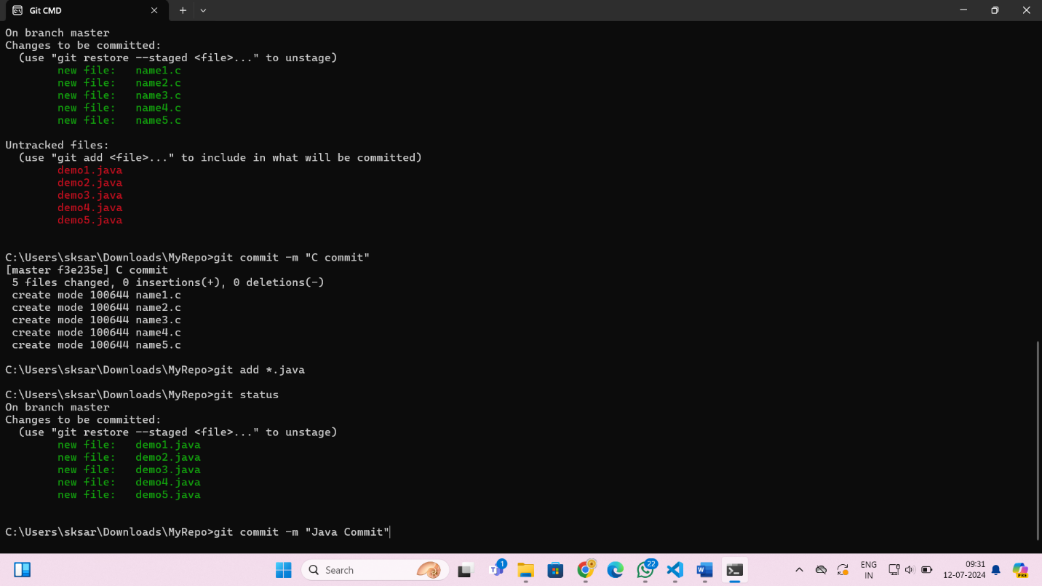

13. Delete all .java files from working area ?

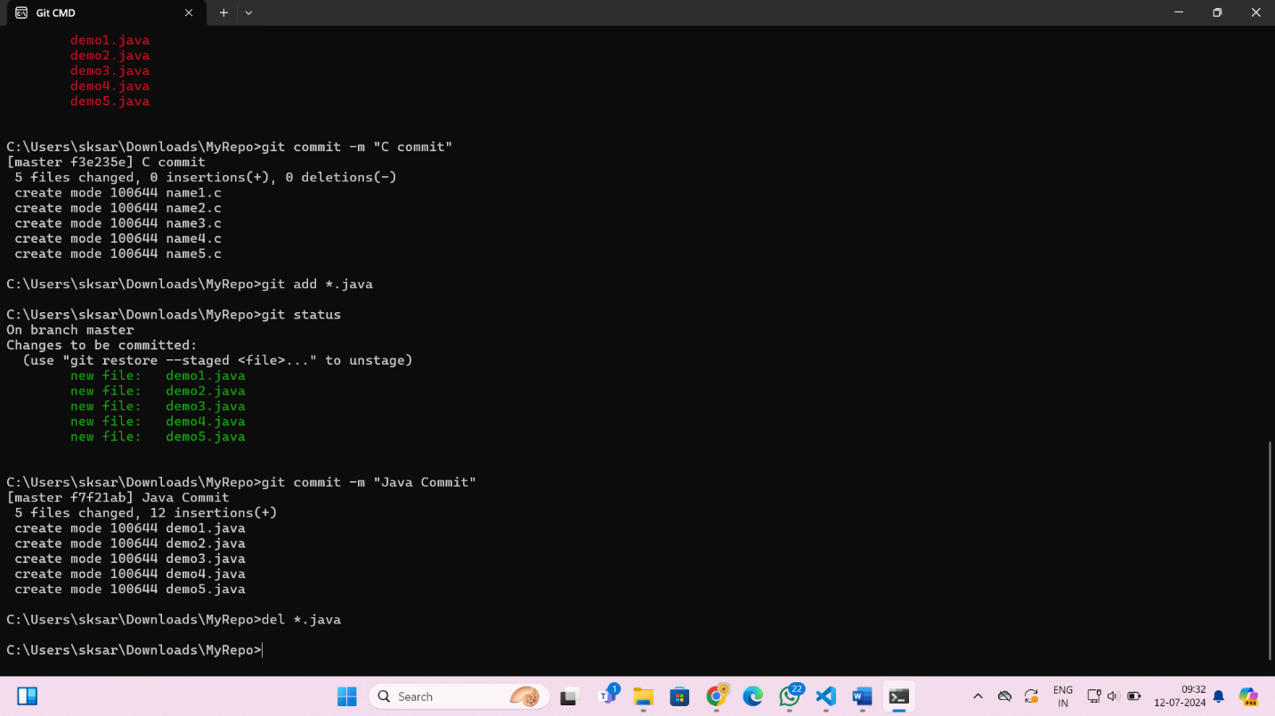

14. Now see the status ?

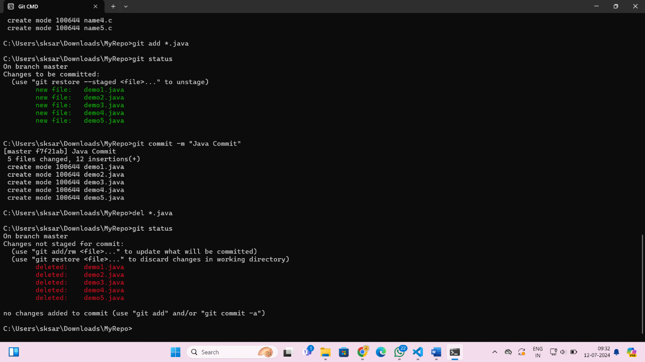

15. add the changes into the staging area ?

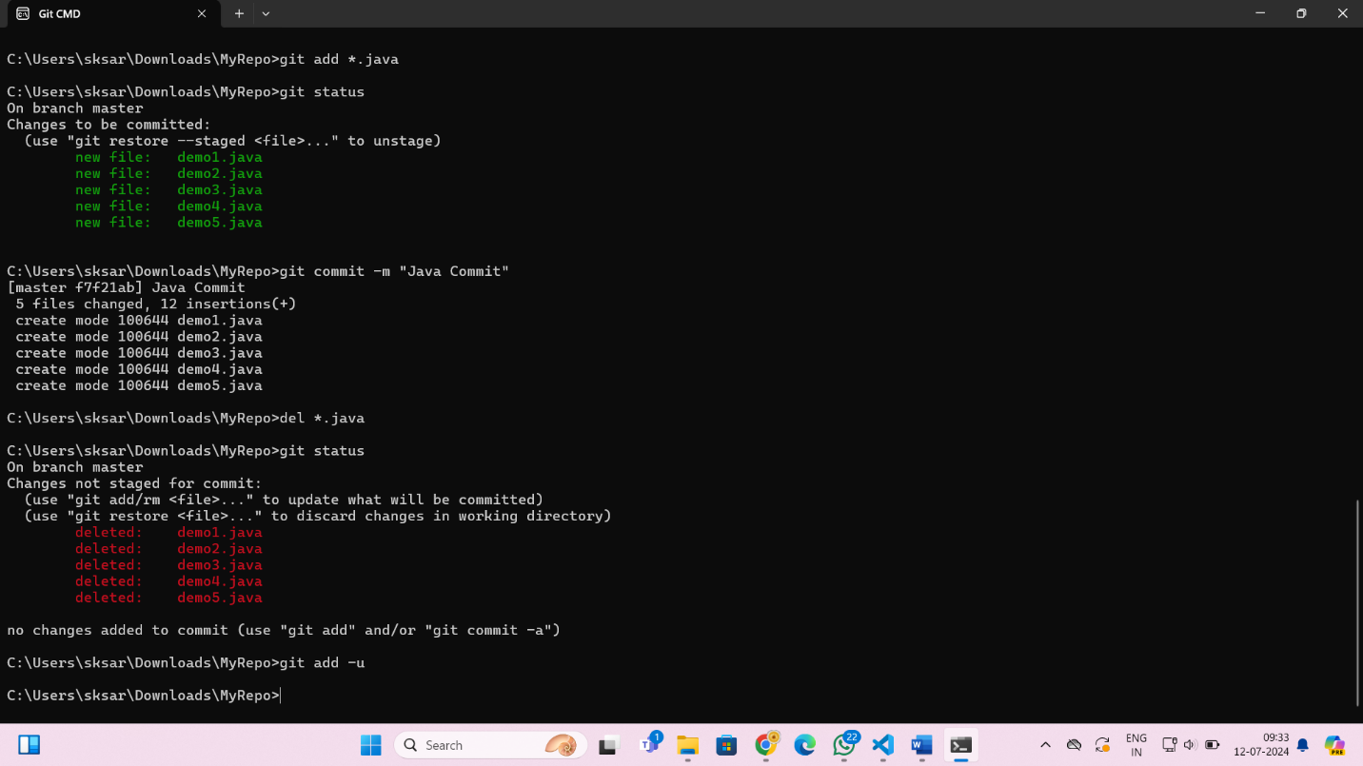

16. Make a commit with the name "Delete Java Commit" ?

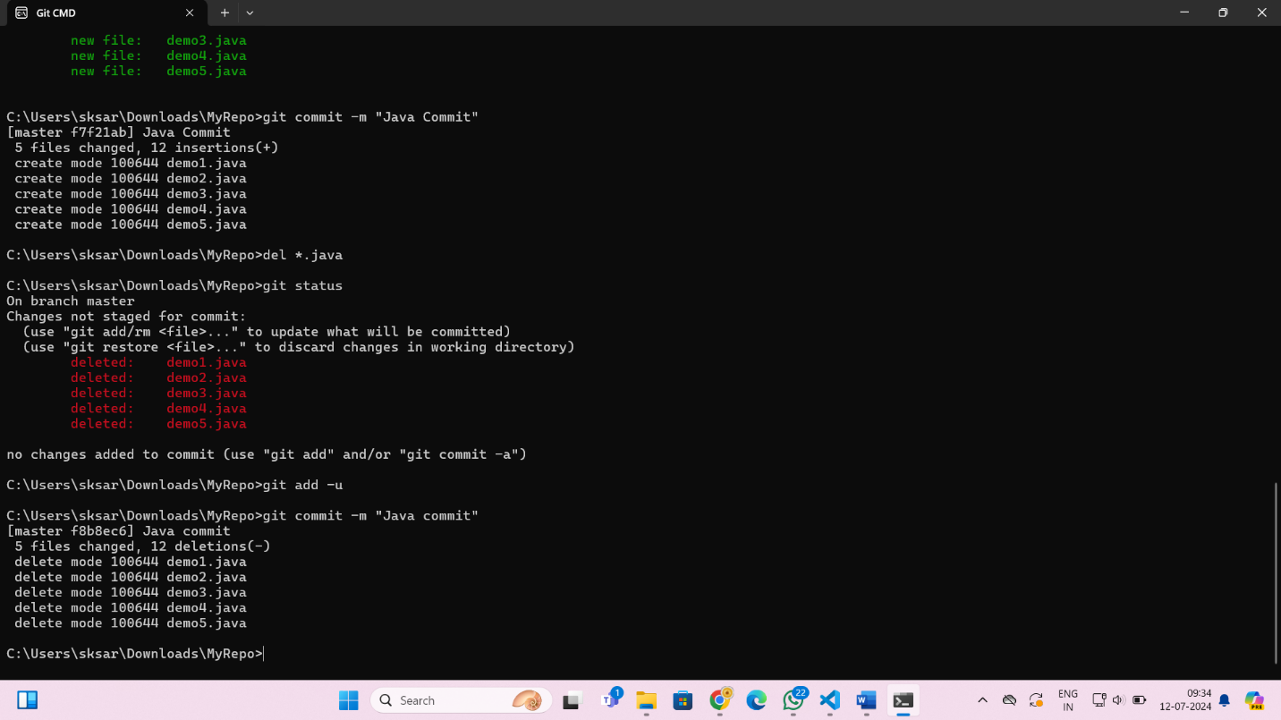

17. display all commit ?

